**In class Programming Assignment - 3**

**GitHub Link:** <https://github.com/Viditha2277/CS-5720/tree/main/Assignment%203>

**Problem 1:** To demonstrate inheritance in Python

**Solution:**

1. Created a class “Employee” and data members to count the no. of instances created for the class Employee and its child class.

2. A constructor is created to initialize the values for the objects and a function “average_salary” is created to calculate average for the employees.

3. Child class “Full_Time_Employee” is created that inherits all the properties of the parent class “Employee” and data members are created to keep track of all the objects.

4. Constructor is defined to initialize the values for the objects and method “average_salary” is created to calculate average salary for the full-time employees.

5. Driver code contains the initialization of objects for both the classes and member functions are called using the objects.

**Code:**

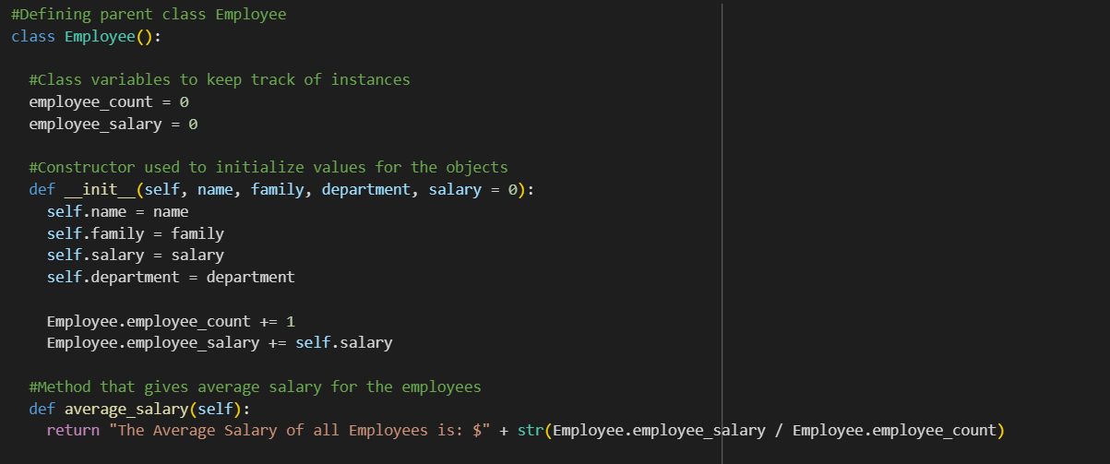

**Output:**



**Problem 2:** To create a random vector of size 20 that contains only floating-point values in the range 1-20, reshaping the vector size from 1x20 to 4x5 and then replacing maximum value in each row to zero.

**Input:**

**Output:** NumPy array

**Solution:**

1. Created a random vector of size 20 with floating-point values using np.arange() method with arguments, range 1-21, type of value (i.e. dtype) as float.

2. Vector is resized using np.reshape() method that takes size of new array as arguments.

3. Maximum value in each row is replaced with 0 using functions np.where() that returns 0 if value is true and remaining elements that has false value, and np.isin() that return Boolean values that is set to true for max value and false for remaining values.

**Code:**

**Output:**

